**[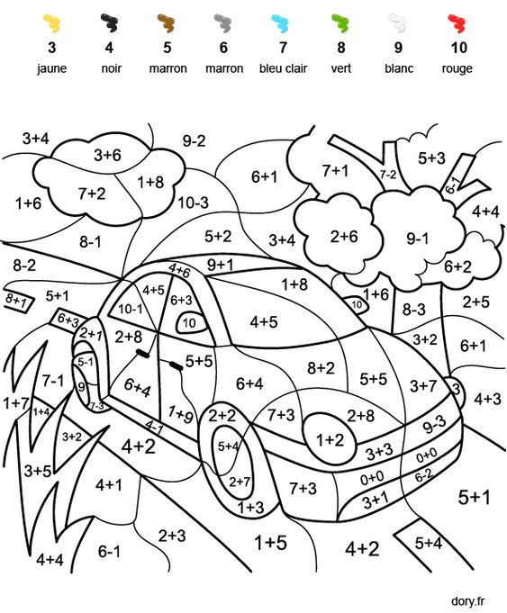](https://easy-plants.dolds.club/coded-coloring-simple-additions-and-subtractions-dory-fr-coloriages-2/?_unique_id=5e736bc20b658)**